Profile of the

West Central Illinois 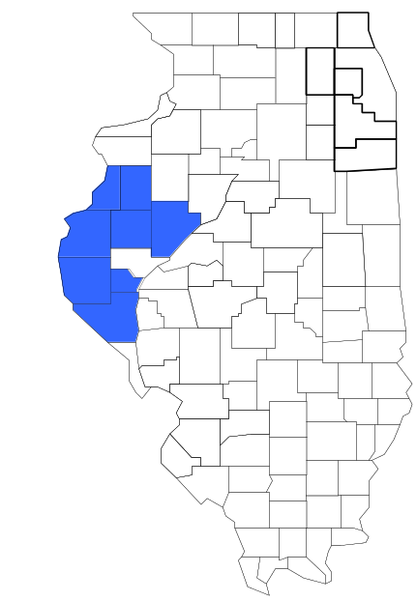Task Force

Prepared by

The Research and Analysis Unit of the
Illinois Criminal Justice Information Authority

George H. Ryan, Governor
Peter B. Bensinger, Chairman
Candice M. Kane, Executive Director

March 2001



ILLINOIS
CRIMINAL JUSTICE
INFORMATION AUTHORITY

This project was supported by Grant # 99-DB-BX-0017, awarded to the Illinois Criminal Justice Information Authority by the Bureau of Justice Assistance, Office of Justice Programs, U.S. Department of Justice. The Assistant Attorney General, Office of Justice Programs, coordinates the activities of the following programs, offices and bureaus: Bureau of Justice Assistance, Bureau of Justice Statistics, National Institute of Justice, Office of Juvenile Justice and Delinquency Prevention, and the Office for Victims of Crime. Points of view or opinions contained within this document are those of the authors and do not necessarily represent the official position or policies of the U.S. Department of Justice.

Illinois Criminal Justice Information Authority
120 S. Riverside Plaza, Suite 1016
Chicago, Illinois 60606-3997
Telephone (312) 793-8550
Telefax (312) 793-8422
TDD: (312) 793-4170
World Wide Website http://www.icjia.state.il.us
ACKNOWLEDGMENTS

A number of organizations and individuals put a great deal of effort into the development of this document. The Authority’s Research and Analysis Unit is very grateful for the assistance provided by the following organizations:

Administrative Office of the Illinois Courts
Illinois Department of Human Services’ Office of Alcoholism and Substance Abuse
Illinois Department of Children and Family Services
Illinois Department of Corrections
Illinois State Police
West Central Illinois Task Force
U.S. Bureau of the Census

In addition, the following individuals were instrumental in gathering, interpreting and presenting these data:

Sharyn Adams

Megan Alderden

Robert Bauer

Alissa Clark

John Condne

Karen Griffiths

Tracy Hahn

Jennifer Hiselman

David Katz

Joseph Kozenczak

Gary Kupsak

Erica Morrow

David Olson

Adrianna Perez

Gerard Ramker

Robert Taylor

CONTENTS

Section Page Number

EXECUTIVE SUMMARY

I. Introduction 1
II. Trends in Violent Index Offenses and Arrests 3
III. Trends in Drug Arrests 6
IV. Trends in Drug Seizures 15
V. Trends in Prosecutions for Drug Offenses 17
VI. Trends in Percent of Convicted Drug Offenders Sentenced to Prison 19
VII. Trends in Drug Treatment Admissions in WCITF Region by Drug Type 24
VIII. Trends in Drug Exposed Births 27
IX. Summary of Drug Situation 28
X. Appendices 30
Map 1 1999 Percent of Illinois' County-level Population Covered by an
Authority-funded Multi-jurisdictional Enforcement Group or Task Force 31
Map 2 1999 Illinois Cannabis Seizure Rates, by County 32
Map 3 1999 Illinois Controlled Substances Seizure Rates, by County 33
Map 4 1999 Illinois Methamphetamine Seizure Rates, by County 34
XI. Bibliography 35

LIST OF FIGURES

Figure Page Number

Figure 1. Violent Index Offense Rates for Participating and Non-participating Agencies in Region Covered by WCITF 3
Figure 2. 1999 Violent Index Offenses* Reported by Participating and Non-participating Agencies in Region Covered by WCITF 4
Figure 3. Violent Index Arrest Rates for Participating and Non-participating Agencies in Region Covered by WCITF 5
Figure 4. 1999 Violent Index Arrests* Reported by Participating and Non-participating Agencies in Region Covered by WCITF 5
Figure 5. Total Drug Arrest Rates for WCITF and Participating and Non-participating Agencies in Region Covered by WCITF 7
Figure 6. 1999 Drug Arrests* Reported by Participating and Non-participating Agencies in Region Covered by WCITF 8
Figure 7. Total 1999 Drug Arrests* Reported by Participating and Non-participating Agencies in Region Covered by WCITF, by Drug Type 8
Figure 8. Drug Arrests by WCITF 9
Figure 9. Percent of Total Drug Arrests Accounted for by WCITF 10
Figure 10. Cannabis Arrests Rates in the Region Covered by WCITF as Reported by Participating Agencies, Non-participating Agencies and WCITF 11
Figure 11. Percent of Cannabis Arrests Accounted for by WCITF
12
Figure 12. Controlled Substances Arrest Rates in the Region Covered by WCITF as Reported by Participating Agencies, Non-participating Agencies and WCITF 13
Figure 13. Percent of Controlled Substances Arrests Accounted for by WCITF 13
Figure 14. WCITF Drug Arrests for Possession versus Delivery, by Drug Type 14
Figure 15. Cannabis Seized and Submitted to ISP by Adams, Brown, Fulton, Hancock, Henderson, McDonough, Pike and Warren Counties and Seized by WCITF 15
Figure 16. Powder and Crack Cocaine Seized and Submitted to ISP by Adams, Brown, Fulton, Hancock, Henderson, McDonough, Pike and Warren Counties and Seized by WCITF 16
Figure 17. Number of Felony Filings in Adams, Brown, Fulton, Hancock, Henderson, McDonough, Pike and Warren Counties 17
Figure 18. Total WCITF Drug Arrests and Percentage of Arrests Resulting in Prosecution 18
Figure 19. Sentences Imposed on Felons Convicted in Adams, Brown, Fulton, Hancock, Henderson, McDonough, Pike and Warren Counties
19
Figure 20. Sentences Imposed on Convicted WCITF Drug Offenders 20
Figure 21. Number of Drug Offenders Committed to IDOC by WCITF and Region Covered by WCITF 21
Figure 22. Drug Offenders as a Percent of Total IDOC Commitments from Adams, Brown, Fulton, Hancock, Henderson, McDonough, Pike and Warren Counties 22
Figure 23. Drug Offenders Committed to IDOC from Adams, Brown, Fulton, Hancock, Henderson, McDonough, Pike and Warren Counties, by Offense Class 23
Figure 24. Substance Abuse Treatment Admissions from Adams, Brown, Fulton, Hancock, Henderson, McDonough, Pike and Warren Counties 24
Figure 25. Comparison of Drug Arrests by WCITF and Participating and Non-participating Agencies vs. Drug Abuse Treatment Admissions in Adams, Brown, Fulton, Hancock, Henderson, McDonough, Pike and Warren Counties, SFY 99 26
Figure 26. Cases of Drug-Exposed Infants in Adams, Brown, Fulton, Hancock, Henderson, McDonough, Pike and Warren Counties 27
Figure 27. Availability of Drugs in Illinois, 1998 28
Figure 28. Price Per Gram in Illinois, 1998 29

EXECUTIVE SUMMARY

Since 1989, the Authority’s Research and Analysis Unit has received funds under the federal Anti-Drug Abuse Act of 1988 to document the extent and nature of drug and violent crime in Illinois and the criminal justice system’s response to these offenses. As a result of these efforts, the Authority has amassed a large amount of data measuring the extent and nature of drug and violent crime in Illinois and the impact these crimes have had on the criminal justice system. In addition, as part of its monitoring and evaluation efforts, the Authority also requires funded programs to submit monthly data reports describing their activities and accomplishments. This profile is intended to provide a general overview of the drug and violent crime problem in the jurisdictions covered by Illinois’ MEGs and task forces, and the response to these problems by the units.

Although the data presented in this report are by no means inclusive of all indicators, they do provide a general overview of drug and violent crime and the response and impact of the criminal justice system. The following represent general conclusions that can be made based on the data analyzed for this report.

- In 1999, 11 local Illinois police agencies participated in WCITF (a participating agency is defined as one that contributes either personnel or financial resources to WCITF). Officers assigned to WCITF (totaling 18 in 1999, 12 from participating agencies) accounted for less than five percent of the total number of sworn police officers working for agencies participating in WCITF.

- The violent Index offense rate was collectively higher across jurisdictions that participated in WCITF than among the combined jurisdictions that did not participate in WCITF (page 3).

- The drug arrest rate was collectively higher in those jurisdictions that participated in WCITF than in those jurisdictions that did not participating in WCITF. The drug arrest rate achieved by WCITF was less than one-half the rate experienced by the participating agencies, meaning the unit made nearly one-half as many arrests for violations of the Cannabis and Controlled Substances Acts, with 18 officers, as did all of the participating agencies combined (page 6).

- When comparing the types of drug offenders arrested by those agencies participating in WCITF, those agencies not participating, and WCITF, it was found that WCITF tended to target and arrest more serious drug law violators, specifically violators of the Controlled Substances Act, which tend to be felony-level offenses (page 9).

- The majority of all drug arrests reported by WCITF, for either violations of the Cannabis Control Act or the Controlled Substances Act, involve drug sale or delivery (page 14).

- Between 1993 and 1999, the amount of cannabis seized by WCITF increased slightly, while the amount of cocaine seized by WCITF increased dramatically (pages 15 and 16).

- Between 1991 and 1999, 97 percent of all drug arrests by WCITF resulted in prosecution. Of those offenders prosecuted, 55 percent were prosecuted for violation of the Controlled Substances Act. In addition, between 1989 and 1999, 88 percent of all drug offenders who were prosecuted as a result of WCITF activity were convicted (page 18).

- In 1999, among those WCITF drug offenders convicted and sentenced, prison sentences accounted for the largest proportion (41 percent), followed by probation sentences (31 percent) and jail sentences (27 percent) (page 20).

- Between 1989 and 1999, prison sentences resulting from WCITF cases accounted for nearly 70 percent of all drug-law violators sent to prison from the region where WCITF operates (page 21).

- Unlike the arrests made by the participating and non-participating agencies, the arrests made by WCITF tended to involve substances considered to be the most serious (i.e., felony versus misdemeanor) and the substances for which a large proportion of community residents were seeking and receiving substance abuse treatment in 1999 (page 25).

I. Introduction

The West Central Illinois Task Force (WCITF) covers the Illinois counties of Adams, Brown, Fulton, Hancock, Henderson, McDonough, Pike and Warren. Combined, these counties had a 1999 total population of 213,883 – one percent more than in 1990. In 1999, 11 local Illinois police agencies participated in WCITF. These include the Adams County Sheriff’s Office, the Brown County Sheriff’s Office, the Fulton County Sheriff’s Office, the Hancock County Sheriff’s Office, the Henderson County Sheriff’s Office, the McDonough County Sheriff’s Office, the Pike County Sheriff’s Office, the Warren County Sheriff’s Office and the following municipal police departments: Canton and Quincy, as well as Western Illinois University. These agencies served 63 percent of the population in the eight-county region covered by WCITF in 1999 (see Map 1 on page 31). A participating agency is defined as one that contributes either personnel or financial resources to WCITF.

In addition to agencies that participate in WCITF, these Illinois counties are served by 28 additional police departments that do not participate in WCITF. According to the Illinois State Police, county sheriffs and local police departments, in the eight-county region covered by WCITF, combined, employed 336 full-time police officers as of Oct. 31, 1999, 242 of which work in agencies participating in WCITF. In comparison, there were a total of just 18 officers assigned to WCITF in 1999, 12 of which were assigned by participating agencies and six from the Illinois State Police (ISP). Thus, the officers assigned to WCITF during 1999 accounted for a relatively small proportion—less than 5 percent—of the total number of sworn police officers working in the participating police departments.

Since 1989, the Authority’s Research and Analysis Unit has received funds under the federal Anti-Drug Abuse Act of 1988 to document the extent and nature of drug and violent crime in Illinois and the criminal justice system’s response to these offenses. As a result of these efforts, the Authority has amassed a large amount of data measuring the extent and nature of drug and violent crime in Illinois and the impact these crimes have had on the criminal justice system. In addition, as part of its monitoring and evaluation efforts, the Authority also requires funded programs to submit monthly data reports describing their activities and accomplishments. To put this information into the hands of Metropolitan Enforcement Group (MEG) and drug task force directors and policy board members, the Authority’s Research and Analysis Unit has developed profiles – of which this is one – for each MEG and task force. The profile is intended to provide a general overview of the drug and violent crime problem in the jurisdictions covered by Illinois’ MEGs and task forces, and the response to these problems by the units.

In addition to administering federal block-grant funds that come to Illinois for crime control initiatives, the Illinois Criminal Justice Information Authority is also responsible for providing policymakers, criminal justice professionals and others with information, tools and technology needed to make effective decisions that improve the quality of criminal justice in Illinois. The Authority provides an objective system-wide forum for identifying critical problems in criminal justice, developing coordinated and cost-effective strategies, and implementing and evaluating solutions to those problems. The specific powers and duties of the Authority are delineated in the Illinois Criminal Justice Information Act (Illinois Compiled Statutes, Ch. 20, Sec. 3930). Two of the Authority’s many responsibilities are serving as a clearinghouse of information and research on criminal justice and undertaking research studies to improve the administration of criminal justice.

While the data presented in this report are by no means inclusive of all indicators, they do provide a general overview of drug and violent crime and the response and impact of the criminal justice system. In addition, these data are readily available and consistently defined through existing statewide data collection mechanisms. Some data presented in this profile have been analyzed differently than in previous years; therefore, caution must be taken when comparing numbers presented with previous profiles.
While a considerable amount of the information presented in this profile has been provided to the Authority by WCITF, a number of state agencies have also provided data to the Authority that are included in this report. Specifically, the Illinois State Police, the Administrative Office of the Illinois Courts, the Illinois Department of Human Services’ Office of Alcoholism and Substance Abuse, the Illinois Department of Corrections and the Illinois Department of Children and Family Services all provided data used to develop this profile. The support and cooperation of these agencies and their staffs have helped make this report an informative and timely source of information on the activities of the criminal justice system in Illinois.
II. Trends in Violent Index Offenses and Arrests

While most of Illinois’ Metropolitan Enforcement Groups and drug task forces are primarily involved in drug enforcement activities, it is clear that the relationship between drugs and violence is particularly evident in a number of Illinois communities. In addition, a number of MEGs and task forces have increased their involvement in the investigation of violent crime, particularly that associated with gang activity and violence related to drug distribution, sale and turf battles. One of the most commonly used indicators of the level of crime in a particular jurisdiction is the number of Index offenses reported to the police. In Illinois, as part of the Illinois Uniform Crime Reporting (I-UCR) program, every law enforcement agency in the state is required to report crime data monthly to the Illinois State Police (ISP). There are eight separate offenses that constitute the Crime Index, including murder, criminal sexual assault, robbery, aggravated assault (violent Index offenses), burglary, theft, motor vehicle theft and arson (property Index offenses). Although these eight offenses do not account for all crimes reported to the police, they are considered to be the most serious, frequent, pervasive and consistently defined by different law enforcement agencies.

In 1999, the total number of violent Index offenses reported to the police in the eight-county region covered by WCITF totaled 712, a 5 percent increase from the 680 offenses reported in 1993. The majority (78 percent) of violent Index offenses reported to the police between 1993 and 1999 were aggravated assaults, while 16 percent were criminal sexual assault.

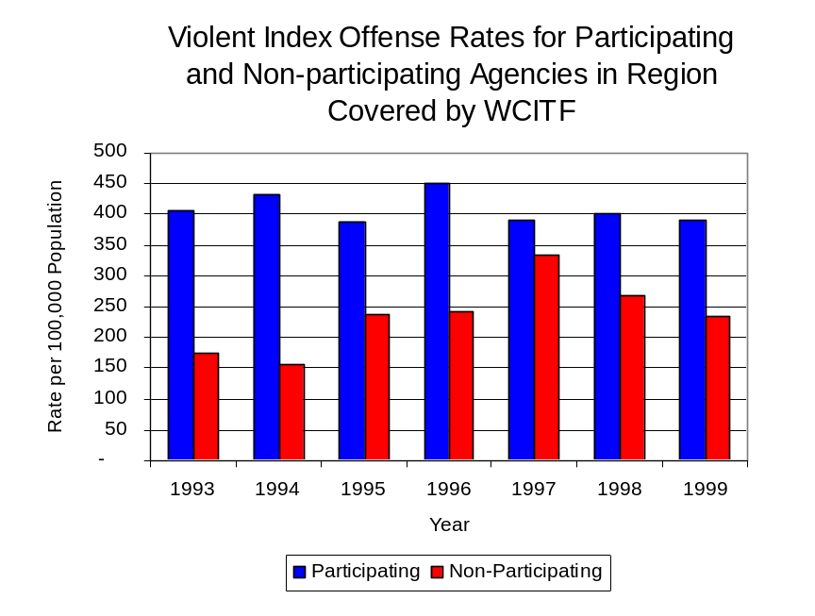
During the period analyzed, the violent Index offense rate for the region covered by WCITF increased 4 percent, from 319 offenses per 100,000 population in 1993 to 333 offenses per 100,000 population in 1999. Conversely, the violent Index offense rate in the participating agencies decreased 4 percent, from 405 to 390 offenses per 100,000 population, while the rate in the non-participating agencies increased 36 percent, from 173 to 235 offenses per 100,000 population (Figure 1). Thus, the violent Index offense rate for participating agencies was collectively greater than the violent Index offense rate for agencies not participating in WCITF.
Source: ICJIA calculations using
Illinois State Police and U.S. Census Bureau data
Figure 1

Across the 39 individual local law enforcement agencies covered by WCITF’s jurisdiction, one agency, the Quincy Police Department, accounted for 34 percent of all violent offenses reported to the police (Figure 2). Twenty-nine agencies had fewer than 25 violent offenses reported in 1999 and are excluded from Figure 2. When controlling for differences in the populations served by these law enforcement agencies, the violent Index offense rate ranged from 608 violent Index offenses per 100,000 population in Quincy to 261 offenses per 100,000 population in Monmouth.
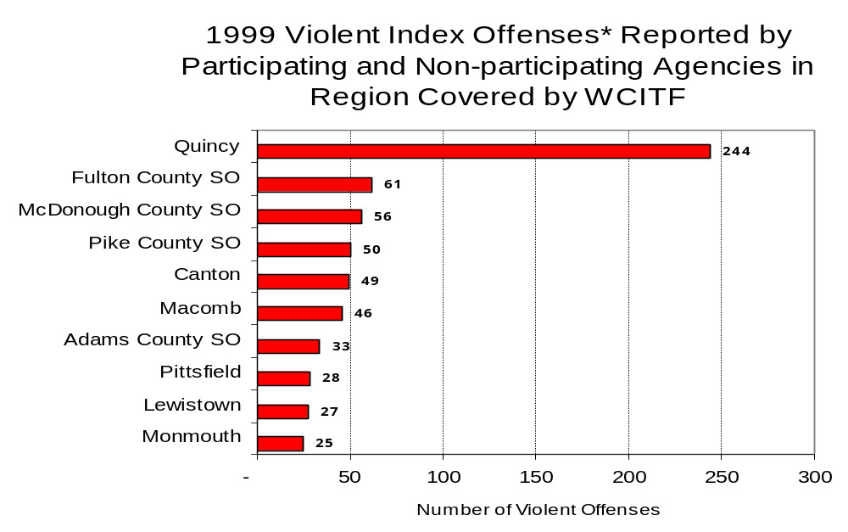
Source: Illinois State Police *Agencies reporting 25 or more violent offenses
Figure 2

An indicator of the workload that law enforcement agencies place on other components of the justice system is the number of arrests made by police, including those for violent and property Index offenses and drug offenses. Unlike offenses, which are what police must respond to, arrests represent those offenders who may eventually be processed through other components of the justice system, including the courts, county jails, and state and local correctional programs.

Between 1993 and 1999, the number of arrests for violent Index offenses made by law enforcement agencies in the region covered by WCITF decreased 16 percent, from 517 to 432. As with reported violent Index offenses, the majority (86 percent) of violent Index arrests were for aggravated assaults, followed by robberies (10 percent).

During the period analyzed, the violent Index arrest rate for the region covered by WCITF decreased 17 percent, from 243 offenses per 100,000 population in 1993 to 202 arrests per 100,000 population in 1999. Similarly, the violent Index arrest rate in the participating agencies decreased 29 percent, from 322 to 229 offenses per 100,000 population, while the rate in the non-participating agencies increased 44 percent, from 107 to 155 offenses per 100,000 population (Figure 3).

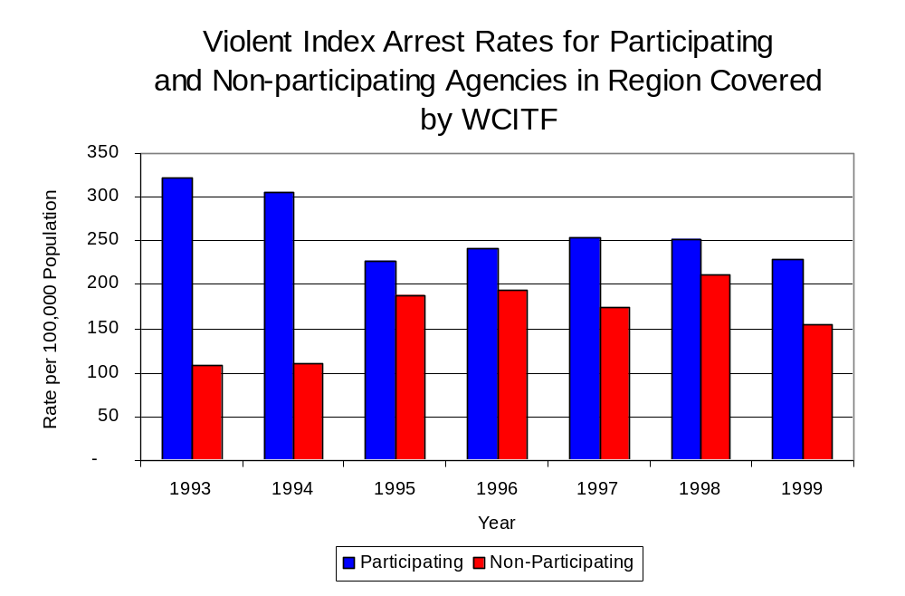
A large percentage (49 percent) of arrests for violent Index offenses occurring in the eight-county region covered by WCITF were made by three agencies. Thirty agencies had fewer than 20 arrests for violent Index offenses reported in 1999 and are excluded from Figure 4. Of the 432 violent Index arrests made in 1999, the Quincy Police Department accounted for the majority (29 percent), followed by the McDonough County Sheriff’s Office (12 percent) and the Canton Police Department (8 percent) (Figure 4).
Figure 3
Source: ICJIA calculations using
Illinois State Police and U. S. Census Bureau data

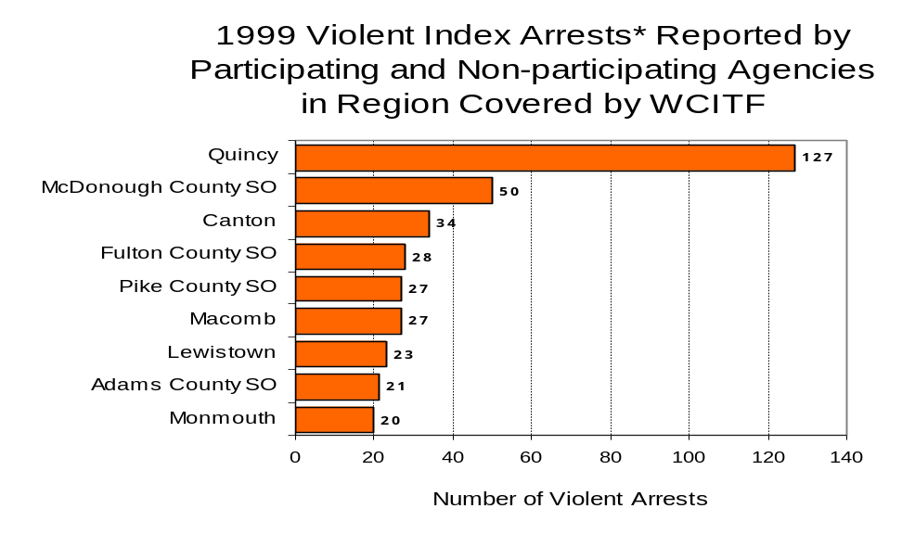
Figure 4
Source: Illinois State Police *Agencies reporting 20 or more violent offenses
III. Trends in Drug Arrests

There are two sources of drug arrest data presented in this section. One source is the Illinois Uniform Crime Reporting (I-UCR) program that includes information submitted by local law enforcement agencies on the number of persons arrested for violations of Illinois’ Cannabis Control Act, Controlled Substances Act, Hypodermic Syringes and Needles Act, and Drug Paraphernalia Control Act. In addition, data on drug arrests made by Illinois’ MEGs and task forces are reported to the Illinois Criminal Justice Information Authority. In some jurisdictions, arrests made by the MEG or task force may be reported by both local law enforcement agencies through the I-UCR and to the Authority by the unit. In other jurisdictions, arrests made by the MEG or task force are only reported to the Authority by the unit. Therefore, in some instances drug arrests may be double counted – included in both local agency statistics reported to I-UCR and those of the MEG or task force. Currently there is no mechanism in place to ensure that drug arrest statistics are not being duplicated at both the local agency and MEG/task force level. This should be kept in mind when interpreting the information presented in the following section.

The majority of drug offenses in Illinois are violations of either the Cannabis Control Act – which prohibits the possession, sale and cultivation of marijuana – or the Controlled Substances Act – which prohibits the possession, sale, distribution or manufacture of all other illegal drugs, such as cocaine and opiates. Illinois also has various other laws prohibiting other drug-related activity. These include the Hypodermic Syringes and Needles Act – which prohibits the possession or sale of hypodermic instruments – and the Drug Paraphernalia Control Act – which prohibits the possession, sale or delivery of drug paraphernalia. In general, violations of Illinois Controlled Substances Act are considered to be more serious, since they primarily involve cocaine, heroin, methamphetamine, and hallucinogens, and are almost all classified under Illinois law as felonies. The majority of cannabis and drug paraphernalia offenses encountered by police, on the other hand, tend to be misdemeanor-level offenses.

In 1999, local law enforcement agencies in the counties covered by WCITF reported 982 arrests for drug law violations, far greater than the number of arrests made in 1993 (270 arrests). Between 1993 and 1999, arrests for violations of Illinois’ Cannabis Control Act out-numbered arrests for violations of the Controlled Substances Act every year in Adams, Brown, Fulton, Hancock, Henderson, McDonough, Pike and Warren counties combined. During the same period, the number of arrests for violations of the Cannabis Control Act in these eight counties combined more than doubled, from 221 to 433. Arrests for violations of the Controlled Substances Act in the eight counties combined more than quadrupled, from 27 to 126. In addition, arrests for violations of the Drug Paraphernalia Control Act, enacted in 1993, increased greatly from 19 in 1993 to 418 in 1999. Much of this increase can be attributed to a 1994 addition to the Drug Paraphernalia Control Act, which included the possession of drug paraphernalia as a violation.

Because arrests for violations of the Drug Paraphernalia Control Act are frequently made in conjunction with other drug offense arrests, these arrests may be double-counted, thus skewing the actual number of drug arrests. Therefore, only arrests for violations of the Cannabis Control Act and Controlled Substances Act will be used for drug arrest comparisons between WCITF and the participating and non-participating agencies.

During the period analyzed, the drug arrest rate for violations of the Cannabis Control and Controlled Substances Acts combined, in the region covered by WCITF more than doubled, from 116 arrests per 100,000 population in 1993 to 261 arrests per 100,000 population in 1999. Similarly, the drug arrest rate in the participating agencies more than doubled, from 138 to 303, while the drug arrest rate for non-participating agencies more than doubled, from 80 to 189 arrests per 100,000 population. The arrest rate for WCITF also increased 63 percent, from 86 to 140 arrests per 100,000 population (Figure 5). Thus, agencies participating in WCITF had a higher drug arrest rate than agencies not participating in WCITF in
six of the seven years analyzed. Also, the drug arrest rate achieved by WCITF was less than one-half the rate experienced by the participating agencies, meaning the unit made nearly one-half as many arrests for violations of the Cannabis and Controlled Substances Acts, with 18 officers, as did all of the participating agencies combined.

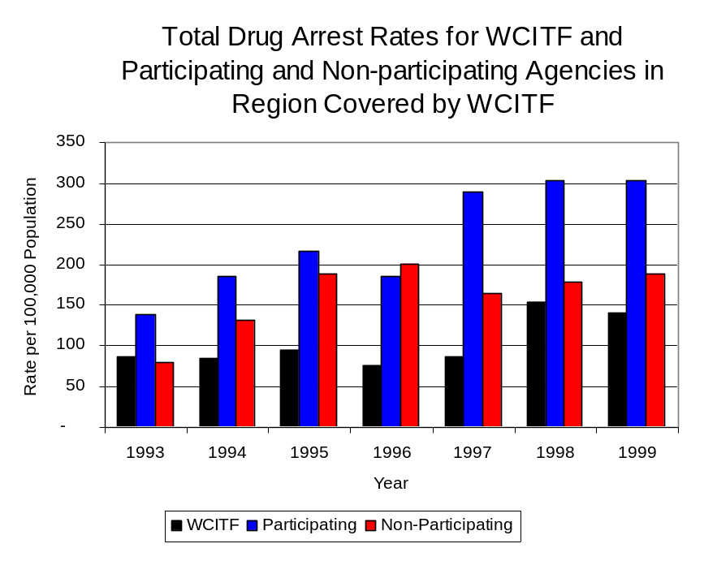
Source: ICJIA calculations using Illinois State Police, WCITF and U.S. Census Bureau data
Figure 5

Across the individual local law enforcement agencies in the region covered by WCITF, the total number of cannabis and controlled substances arrests ranged from zero to 187. Of the 559 drug arrests made during 1999 in the eight-county region, four agencies accounted for 64 percent of these drug arrests. Twenty-nine agencies had fewer than ten drug arrests reported in 1999 and are excluded from Figure 6. Quincy accounted 33 percent, while the Canton and Macomb Police Departments accounted for 11 percent and the Monmouth Police Department accounted for 8 percent of all drug arrests made in Adams, Brown, Fulton, Hancock, Henderson, McDonough, Pike and Warren counties (Figure 6). Among the nine agencies with the highest number of drug arrests during 1999, seven participated in WCITF.

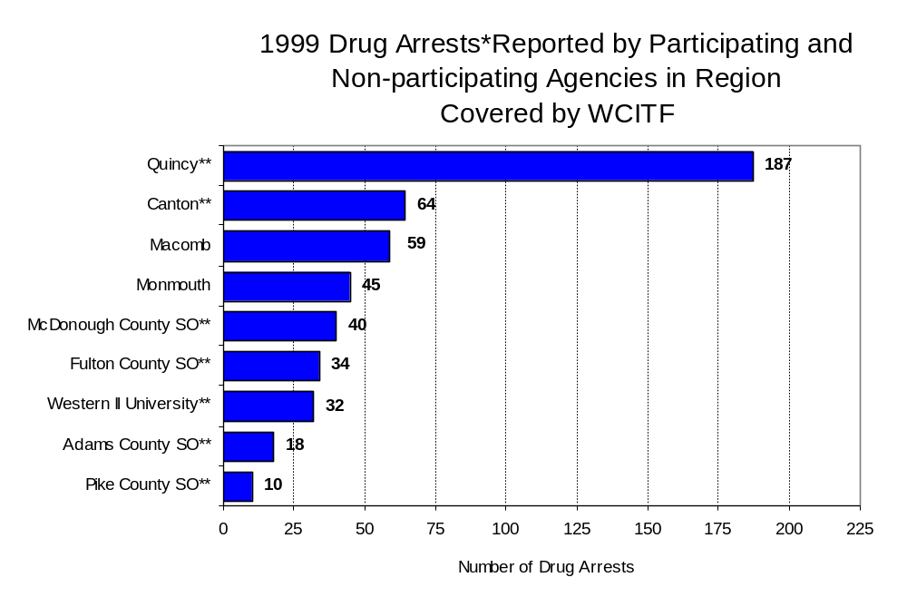
In addition to the dramatic difference in the number of drug arrests made, there are also
Figure 6
Source: Illinois State Police *Agencies reporting ten or more drug arrests
**Agencies participating in WCITF
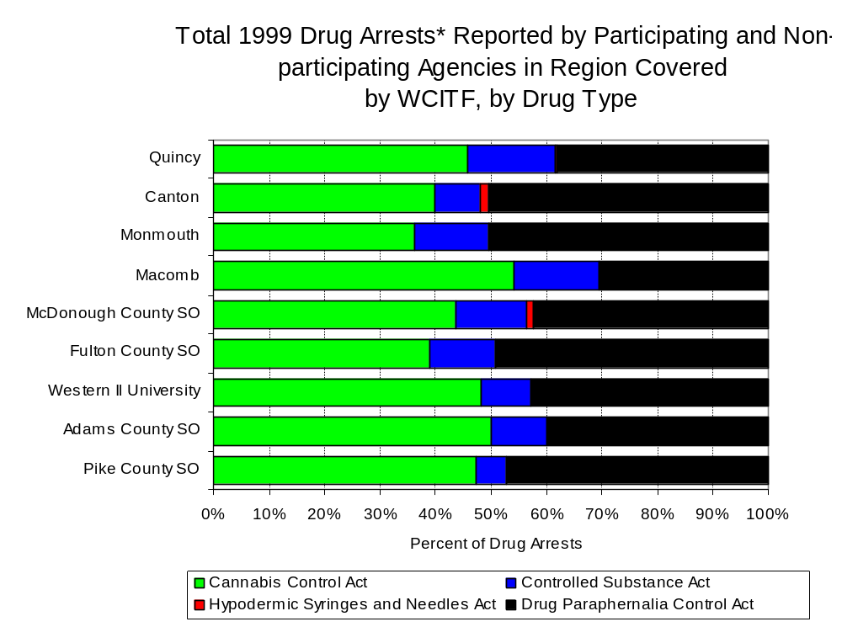
differences in the types of drug law violation arrests across the agencies in the region. In 1999, violations of the Cannabis Control Act and the Drug Paraphernalia Control Act accounted for the majority of arrests across most individual agencies in the region covered by WCITF (Figure 7).
Figure 7
Source: Illinois State Police *Agencies reporting ten or more drug arrests

Between 1993 and 1999, the number of combined cannabis and controlled substances arrests made by WCITF increased 62 percent, from 115 to 189 (Figure 8). Unlike drug arrests made by most local police departments in the region, violations of the Controlled Substances Act accounted for the majority of drug arrests made by WCITF throughout most of the period analyzed. During the period analyzed, the number of WCITF arrests for violations of the Cannabis Control Act increased 25 percent, from 63 to 91, while arrests for violations of the Controlled Substances Act increased from 52 to 98 (Figure 8).

Between 1993 and 1999, the proportion of drug arrests accounted for by violations of the Controlled Substances Act increased for participating and non-participating agencies. In addition, for WCITF, the proportion of drug arrests accounted for by controlled substance violations also increased between 1993 and 1999. In 1999, 52 percent of the drug arrests made by WCITF were for violations of the Controlled Substances Act, compared to 45 percent in 1993; whereas, in 1999, arrests for controlled substances violations accounted for 22 percent of the drug arrests made in the participating agencies and 23 percent for the non-participating agencies, compared to 11 percent and 10 percent, respectively, in 1993. Thus, arrests by WCITF were more likely than arrests by participating or non-participating agencies to involve violations of the Illinois’ Controlled Substances Act, as opposed to the Cannabis Control Act. One interpretation of this pattern is that WCITF was slightly more focused in who they were targeting and arresting for violations of the Controlled Substances Act than local departments, and were also getting a more serious drug law violator, since violations of the Controlled Substances Act are more likely to involve felony-level offenses.

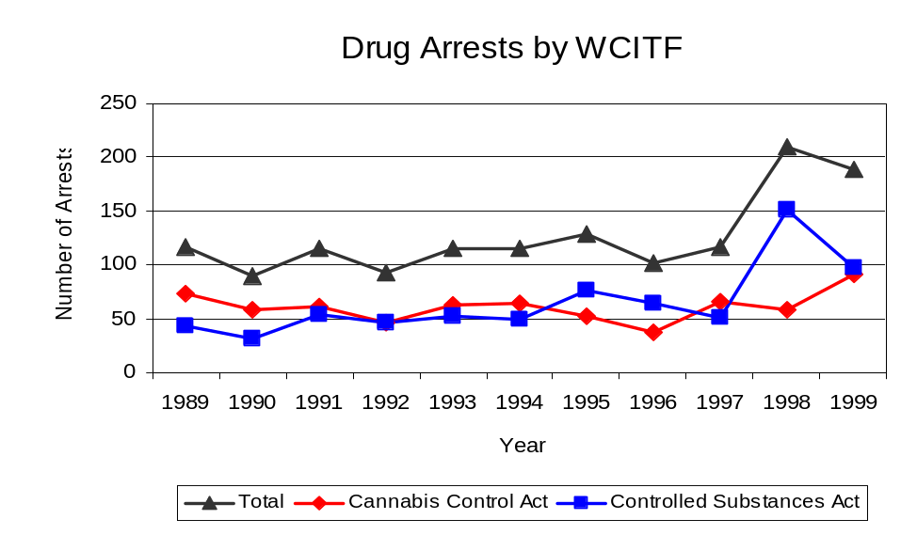
Source: WCITF
Figure 8

The data presented below represent the percent of total drug arrests made by participating agencies that were accounted for by WCITF. An upper and lower bound is shown in Figure 9, which accounts for whether or not the units numbers are counted as part of the UCR submissions made by participating departments (which is unknown at this point). The upper bound indicates the percentage of arrests if all of the WCITF arrests are included in the local UCR submissions. The lower bound indicates the percentage if none of the WCITF arrests are included in the local UCR submissions.

It is estimated that the proportion of all drug arrests made in the jurisdictions of participating agencies, and accounted for by WCITF, was between 38 to 62 percent in 1993, but decreased to between 32 to 46 percent in 1999. Thus, despite the fact that the officers assigned to WCITF accounted for a small proportion of the total number of officers in participating agencies, they accounted for a relatively large proportion of the drug arrests made in the jurisdiction of the participating agencies in most of the years analyzed.
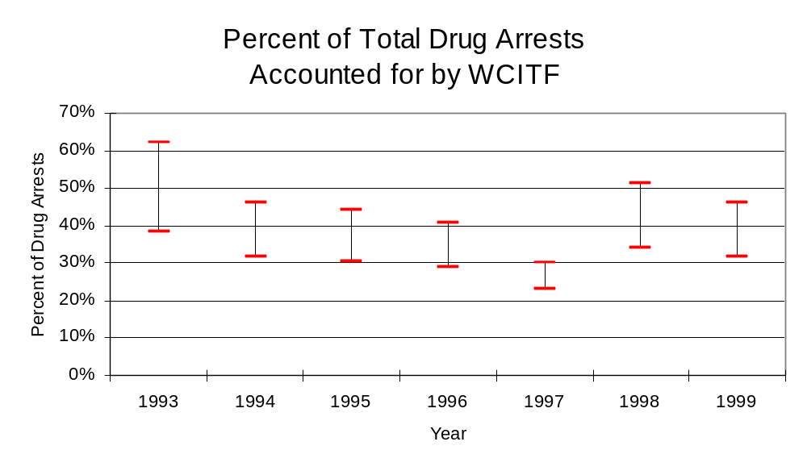
Figure 9
Source: ICJIA calculations using
Illinois State Police and WCITF data

The number of arrests for violations of Illinois’ Cannabis Control Act in Adams, Brown, Fulton, Hancock, Henderson, McDonough, Pike and Warren counties totaled 433 in 1999, 96 percent more the 221 arrests made for cannabis violations in 1993. Between 1993 and 1999, the proportion of all drug arrests accounted for by violations of the Cannabis Control Act in the eight-county region decreased 13 percent, increasing from 89 percent to 77 percent. Agencies participating in WCITF accounted for the largest portion (70 percent) of the total number of arrests for cannabis violations. WCITF reported a total of 91 arrests for cannabis violations in 1999, 48 percent of the unit's drug arrests.

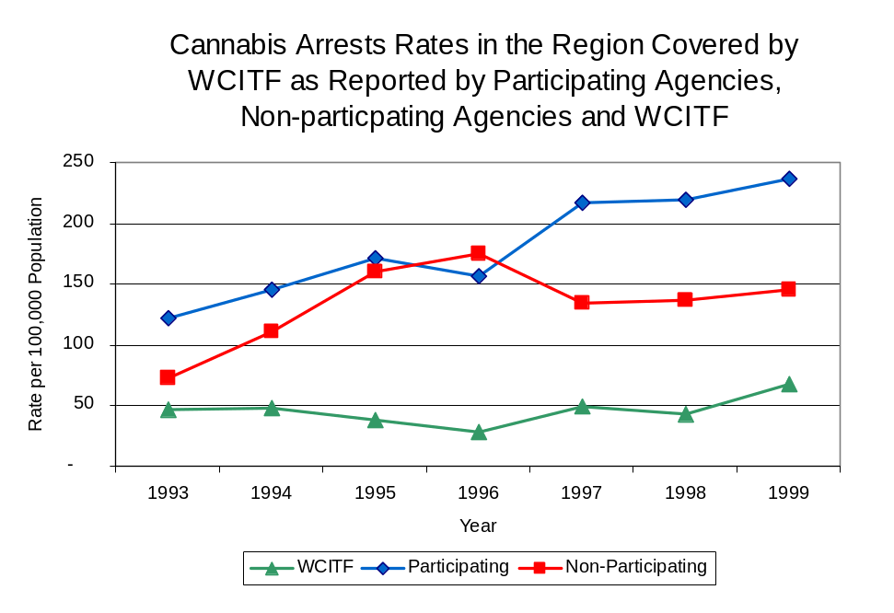
During the period analyzed, the cannabis arrest rate for the region covered by WCITF increased 95 percent, from 104 arrests per 100,000 population in 1993 to 202 arrests per 100,000 population in 1999. The cannabis arrest rate in the participating agencies increased 93 percent, from 122 to 236 arrests per 100,000 population, while the arrest rate in the non-participating agencies doubled from 72 to 145 arrests per 100,000 population. The cannabis arrest rate for WCITF also increased 43 percent, from 47 to 67 arrests per 100,000 population (Figure 10). Thus, prior to 1997, the drug arrest rate for violations of the Cannabis Control Act in non-participating agencies was higher than those agencies participating in WCITF. Since 1997, however, the drug arrest rate for violations of the Cannabis Control Act for agencies participating in WCITF was higher than the arrest rate for non-participating agencies.
Source: ICJIA calculations using
Illinois State Police and WCITF data
Figure 10

The data presented in Figure 11 represent the percent of cannabis arrests made by participating agencies accounted for by WCITF. An upper and lower bound is shown which accounts for whether or not the unit’s numbers are counted as part of the UCR submissions made by local departments (which is unknown at this point). The upper bound indicates the percentage of arrests if all of the WCITF arrests are included in the local UCR submissions. The lower bound indicates the percentage if none of the WCITF arrests are included in the local UCR submissions. It is estimated that the proportion of cannabis arrests across participating agencies accounted for by WCITF was between 28 to 38 percent in 1993, but decreased slightly to between 22 to 29 percent in 1999.

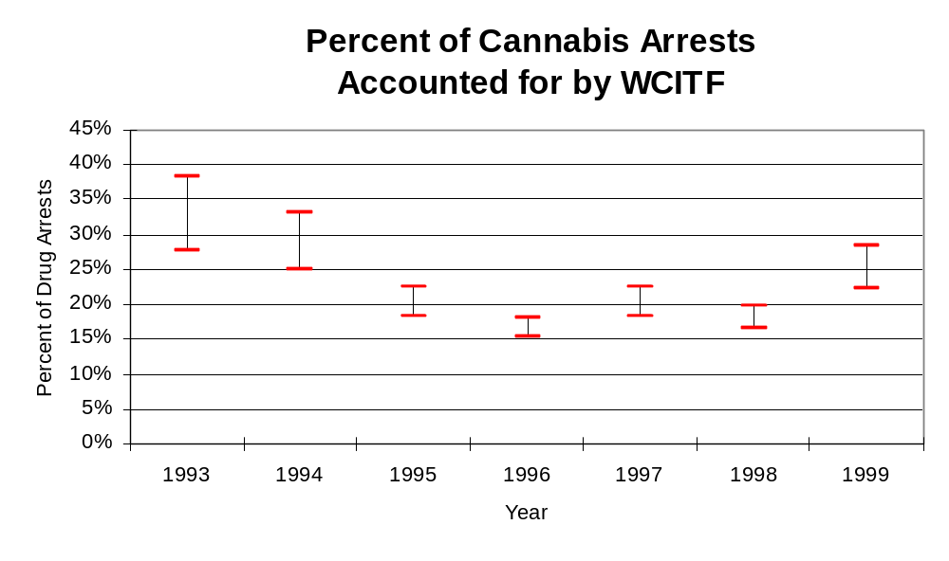
Figure 11
Source: ICJIA calculations using
Illinois State Police and WCITF data

In Adams, Brown, Fulton, Hancock, Henderson, McDonough, Pike and Warren counties the number of arrests for violations of Illinois’ Controlled Substances Act more than quadrupled between 1993 and 1999, from 27 to 126. Between 1993 and 1999, the proportion of all drug arrests accounted for by violations of the Controlled Substances Act in the eight-county region increased from 11 percent to 23 percent. In 1999, WCITF reported 98 arrests for controlled substance violations, 56 percent of all drug arrests reported to the Authority by the unit.

Between 1993 and 1999, the arrest rate for controlled substances act violations for the region covered by WCITF more than doubled, from 116 to 261 arrests per 100,000 population (Figure 12). The controlled substances arrest rates in the participating and non-participating agencies also more than doubled, from 138 to 303 arrests per 100,000 population and 80 to 189 arrests per 100,000 population, respectively. The controlled substances arrest rate for WCITF increased 63 percent, from 86 to 140 arrests per 100,000 population (Figure 12). Thus, the Controlled Substances Act arrest rate was collectively higher in the participating agencies than the non-participating agencies.

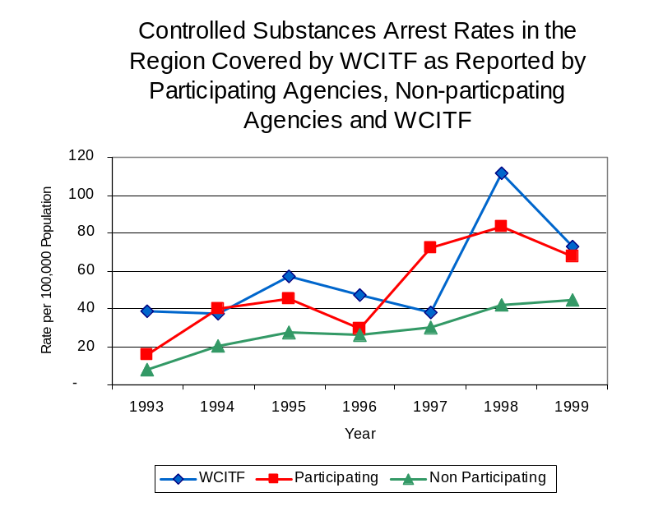
The data presented in Figure 13 represent the percent of controlled substances arrests made by participating agencies accounted for by WCITF. An upper and lower bound is shown which accounts for whether or not the units numbers are counted as part of the UCR submissions made by local departments which is unknown at this point). The upper bound indicates the percentage of arrests if all of the WCITF arrests are included in the local UCR submissions. The lower bound indicates the percentage if none of the WCITF arrests are included in the local UCR submissions. Because values of the upper bound exceed 100 percent, it is believed that WCITF controlled substances arrests are included in local agency UCR submissions and, according to the lower bound, it is estimated that the proportion of controlled substances arrests across participating agencies accounted for by WCITF remained relatively stable throughout the period analyzed accounting for approximately 71 percent in 1993, but decreased to 52 percent in 1999.
Figure 12
Source: ICJIA calculations using Illinois State Police and WCITF data
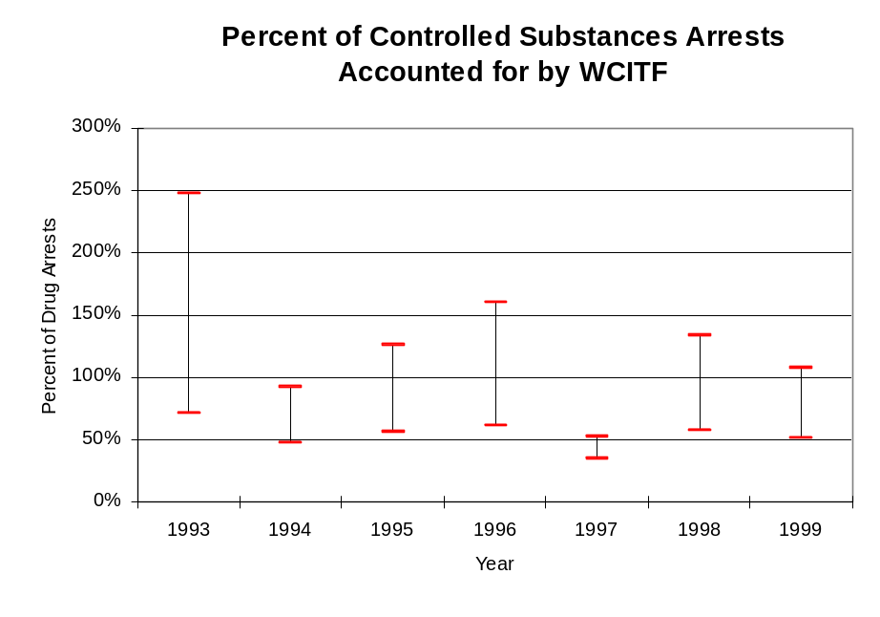
Figure 13
Source: ICJIA calculations using
Illinois State Police and WCITF data

The majority (two-thirds) of all drug arrests reported by WCITF is for delivery. Between 1993 and 1999, the number of drug delivery arrests made by WCITF increased 44 percent, from 94 to 135. However, drug delivery offenses accounted for a decreasing proportion of arrests, decreasing from 82 percent in 1993 to 71 percent in 1999. When cannabis and controlled substance arrests were examined separately, during the period analyzed, arrests for delivery of controlled substances and cannabis varied somewhat. While arrests for delivery of cannabis accounted for 65 percent of all WCITF cannabis arrests during the period analyzed, they accounted for a decreased proportion, decreasing from 95 percent in 1993 to 68 percent in 1999; however that proportion has steadily increased during the past four years. Arrests for the delivery of controlled substances, on the other hand, has accounted for an increased proportion of cannabis arrests between 1993 and 1999, increasing from 65 to 75 percent of all arrests for violations of the Controlled Substance Act.
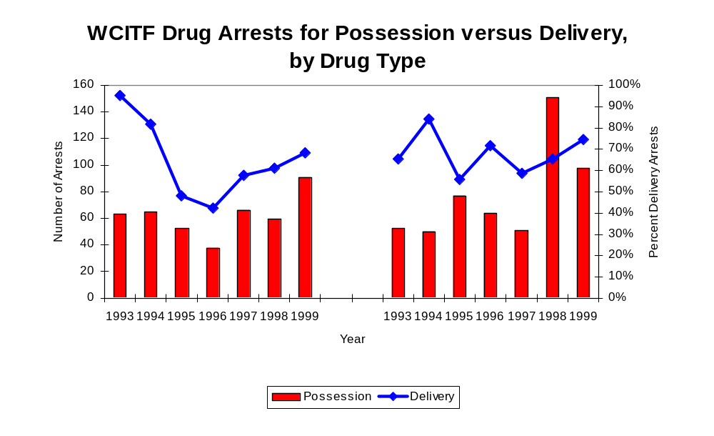
Figure 14
Source: ICJIA calculations using WCITF data
Cannabis Control Act

Controlled Substances Act

IV. Trends in Drug Seizures

Drugs seized by law enforcement agencies are another indicator of the extent and nature of illegal drug trade in a jurisdiction. When illegal drugs are seized by law enforcement agencies, all or a portion of the total amount seized is submitted to a crime lab for analysis. Most agencies submit drugs to one of the Illinois State Police crime labs. These labs record the quantity of drugs submitted from each county. This section discusses trends in the quantities of illegal drugs seized and submitted to the Illinois State Police from local law enforcement agencies in Adams, Brown, Fulton, Hancock, Henderson, McDonough, Pike and Warren counties as well as the quantities of drugs seized by WCITF. It is important to note, however, that while WCITF data report the total quantities of drugs actually seized, local agency data only represent the quantities of seized drugs that are submitted to the Illinois State Police for analysis. County-level cannabis, cocaine and methamphetamine seizure rates for Illinois' 102 counties are provided in maps located in the Appendix of this report.

As in most Illinois jurisdictions, cannabis accounts for the majority of illegal drugs seized in the eight-county region covered by WCITF. The quantity of cannabis seized and submitted by law enforcement agencies in Adams, Brown, Fulton, Hancock, Henderson, McDonough, Pike and Warren counties increased 16 percent, from 13,535 grams in 1993 to 15,648 grams in 1999, with 23,302 grams being seized in 1994, the largest amount seized during the period analyzed. However, although the quantity of cannabis seized by WCITF remained nearly unchanged between 1993 and 1999, increasing slightly from 23,785 grams to 23,823 grams, the quantity of cannabis seized by WCITF jumped to 130,391 grams in 1995 and 141,527 grams in 1997 (Figure 15). In 1999, WCITF's cannabis seizure rate of 17,622 grams per 100,000 population was 44 percent lower than the statewide cannabis seizure rate of 31,533 grams per 100,000 population, but more than double the seizure rate of 7,316 grams per 100,000 population in the eight-county region covered by WCITF (Map 2).
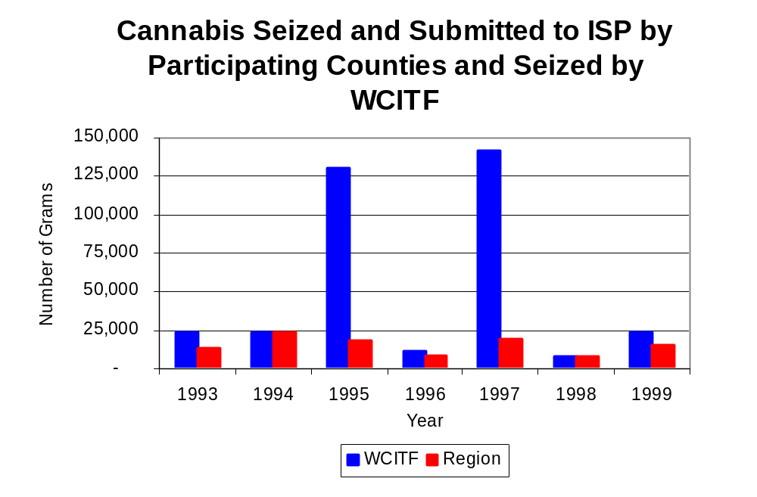
Figure 15
Source: Illinois State Police and WCITF

Between 1993 and 1999, a combination of crack and powder cocaine has accounted for a small proportion of drugs seized in the eight-county region covered by WCITF. However, the quantity of cocaine seized and submitted by law enforcement agencies in Adams, Brown, Fulton, Hancock, Henderson, McDonough, Pike and Warren counties increased more than four-fold, from 200 grams in 1993 to 1,026 grams in 1999. Between 1993 and 1999, the quantity of cocaine seized by WCITF increased more than five-fold, from 26 grams to 157 grams.

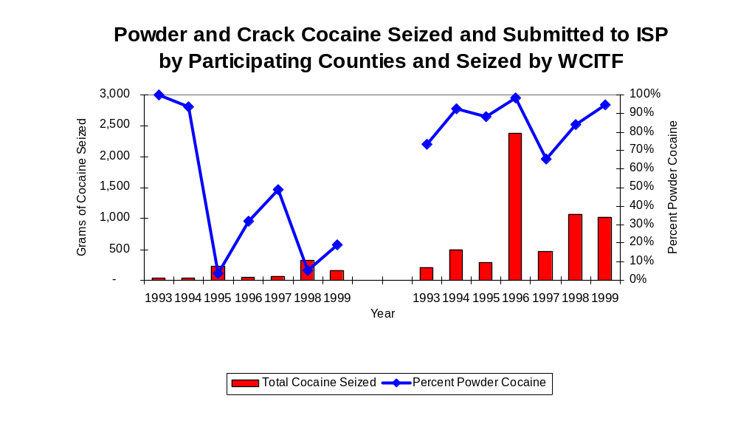
As a result, the proportion of all cocaine seized by the region covered by WCITF accounted for by powder cocaine remained relatively stable between 1993 and 1999, whereas WCITF seizures revealed a significant variation. Although powder cocaine accounted for nearly two-thirds of all cocaine seized in the eight-county region covered by WCITF, the proportion increased between 1993 and 1999 from 73 percent to 95 percent. For WCITF, although powder cocaine accounted for 43 percent of total cocaine seizures during the period analyzed, the proportion decreased from 100 percent in 1993 to 19 percent in 1999 (Figure 16). In 1999, WCITF's cocaine seizure rate of 116 grams per 100,000 population was less than one-third the cocaine seizure rate of 480 grams per 100,000 population in the eight-county region covered by WCITF, and significantly less than the statewide cocaine seizure rate of 15,735 grams per 100,000 population (Map 3).
Figure 16
Source: Illinois State Police and WCITF
WCITF
Region

The total quantity of illegal drugs seized and submitted by law enforcement agencies in Adams, Brown, Fulton, Hancock, Henderson, McDonough, Pike and Warren counties increased 29 percent between 1993 and 1999, from 13,844 grams to 17,898 grams. In addition, the total quantity of illegal drugs seized by WCITF increased 18 percent, from 23,952 grams in 1993 to 28,182 grams in 1999.

Between 1993 and 1999, WCITF reported 4,498 grams of methamphetamine seizures, more than tripling over the past two years. During this period 2,424 grams of methamphetamine were seized in the region covered by WCITF. WCITF's methamphetamine seizure rate of 2,579 grams per 100,000 population was more than triple the rate of 712 grams per 100,000 population seized in the eight-county region covered by WCITF, and significantly higher than the statewide rate of 98 grams per 100,000 population (Map 4).

Trends in Prosecutions for Drug Offenses and All Felonies

Although Illinois has one of the best court reporting systems in the country, the Administrative Office of the Illinois Court only collects information regarding the aggregate number of court filings. Currently, there are no statewide data available on court filings by offense type. The Administrative Office of the Illinois Courts reports data on felony criminal court cases. After screening a case and deciding it warrants further action, the state’s attorney must file formal charges in court. Felony cases can be punished by a probation term up to four years and incarceration for more than one year.

Between 1989 and 1999, the number of felony filings in the eight-county region covered by WCITF increased 36 percent, from 1,011 to 1,380 (Figure 17).

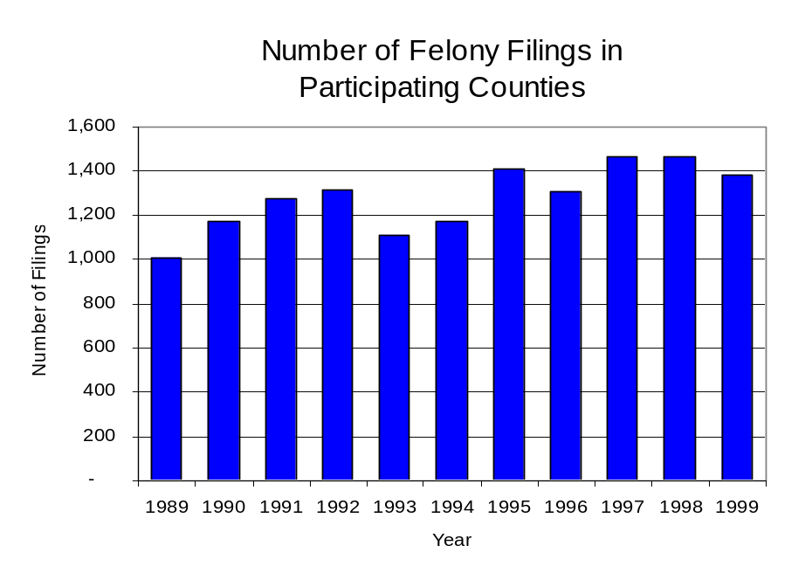
Figure 17
Source: Administrative Office of the Illinois Courts

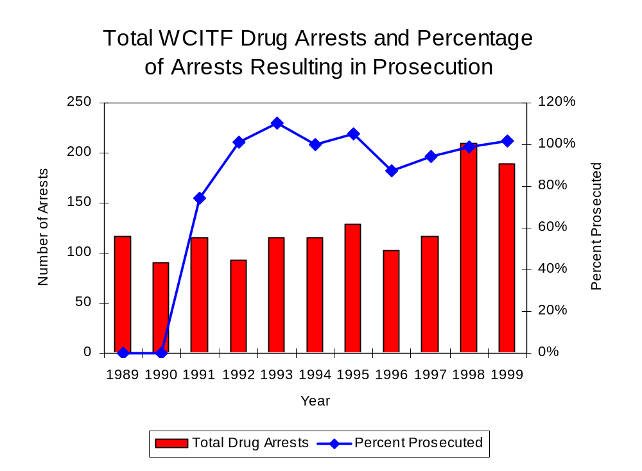
Between 1989 and 1999, there were a total of 1,157 drug prosecutions initiated as a result of WCITF arrests in Adams, Brown, Fulton, Hancock, Henderson, McDonough, Pike and Warren counties. During this time, the number of WCITF drug arrests increased 62 percent, from 117 arrests in 1989 to 189 arrests in 1999 (Figure 18). While no prosecutions were reported in 1989 or 1990, between 1991 and 1999, approximately 97 percent of drug arrests by WCITF resulted in prosecution. More than one-half (55 percent) of WCITF drug offender prosecutions during this period were for violations of the Controlled Substance Act. In some years, the proportion of arrests resulting in a prosecution exceeded 100 percent. This is due to some slight differences in the timing of an arrest and the filings of charges, or could be due to charges, rather than defendants, being reported by the unit. In addition, some offenders have charges filed, and a subsequent warrant issued, without an arrest taking place.
Figure 18
Source: WCITF

Between 1989 and 1999, 88 percent (1,023) of the 1,157 drug offenders who were prosecuted as a result of WCITF activity were convicted. Convictions for controlled substances accounted for one-half of all WCITF initiated convictions during the period analyzed.

VI. Trends in Percent of Convicted Drug Offenders Sentenced to Prison

Anyone convicted of a felony in Illinois can be sentenced either to prison or probation, or receive conditional discharge. A number of factors influence the type and length of sentence imposed on convicted felons, including the severity of the crime, the offender’s criminal and social history, safety of the community and legislation affecting certain types of offenses. For some types of convictions, a sentence to prison is required by state statute.

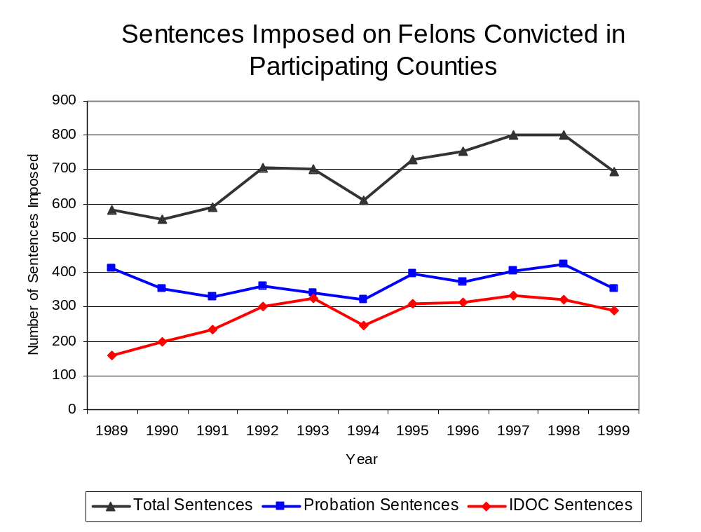
Between 1989 and 1999, the number of offenders convicted of a felony and sentenced in the eight-county region covered by WCITF increased 19 percent, from 581 to 693. The number of convicted felons sentenced to the Illinois Department of Corrections (IDOC) increased 84 percent between 1989 and 1999, from 158 to 290. As a result, the proportion of felons sentenced to IDOC increased during the same period, from 27 percent to 42 percent of total felony sentences. In 1999, 354 probation sentences were imposed on convicted felons, 14 percent less than the 411 probation sentences in 1989 (Figure 19). As a result, the proportion of felons sentenced to probation decreased from 71 percent in 1989 to 51 percent in 1999. Sentences other than prison or probation account for the remaining 7 percent of felony sentences imposed in 1999.
Figure 19
Source: Administrative Office of the Illinois Courts

Between 1991 and 1999, the number of WCITF drug offenders convicted and sentenced increased 32 percent, from 83 to 131. During the period analyzed, the number of convicted WCITF drug offenders sentenced to prison more than doubled, from 26 in 1989 to 54 in 1999. Similarly, the number of convicted WCITF drug offenders sentenced to probation and jail also increased during the period, from 25 to 41 ( 64 percent increase) and 32 to 36 ( a 13 percent increase), respectively (Figure 20). In 1999, among those WCITF drug offenders convicted and sentenced, prison sentences accounted for the largest proportion (41 percent), followed by probation sentences (31 percent) and jail sentences (27 percent).

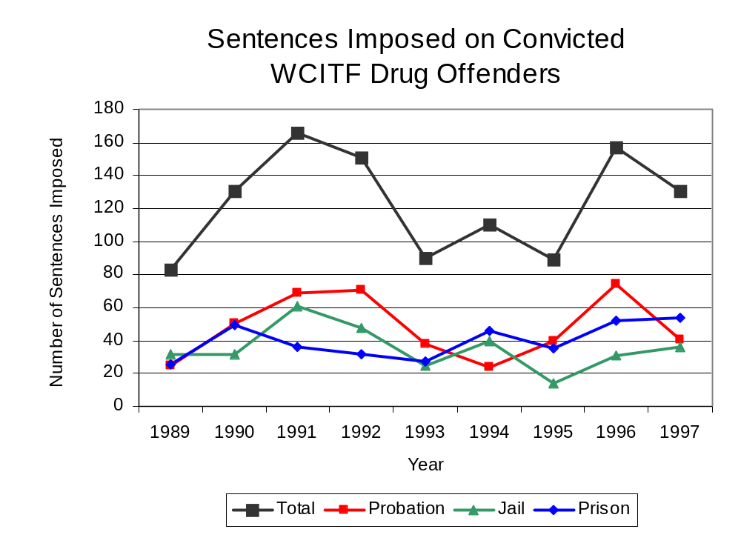
Figure 20
Source: WCITF

Between state fiscal years 1989 and 1999, the number of new court commitments to IDOC’s Adult Division for drug offenses from the eight-county region covered by WCITF more than quadrupled, from 19 to 77. The number of drug offender admissions by WCITF also increased significantly between 1989 and 1999, from zero to 61 (Figure 21). Thus, during the period analyzed, prison sentences resulting from WCITF cases accounted for nearly seven out of every ten drug-law violators sentenced to prison from the eight-county region where WCITF operates.

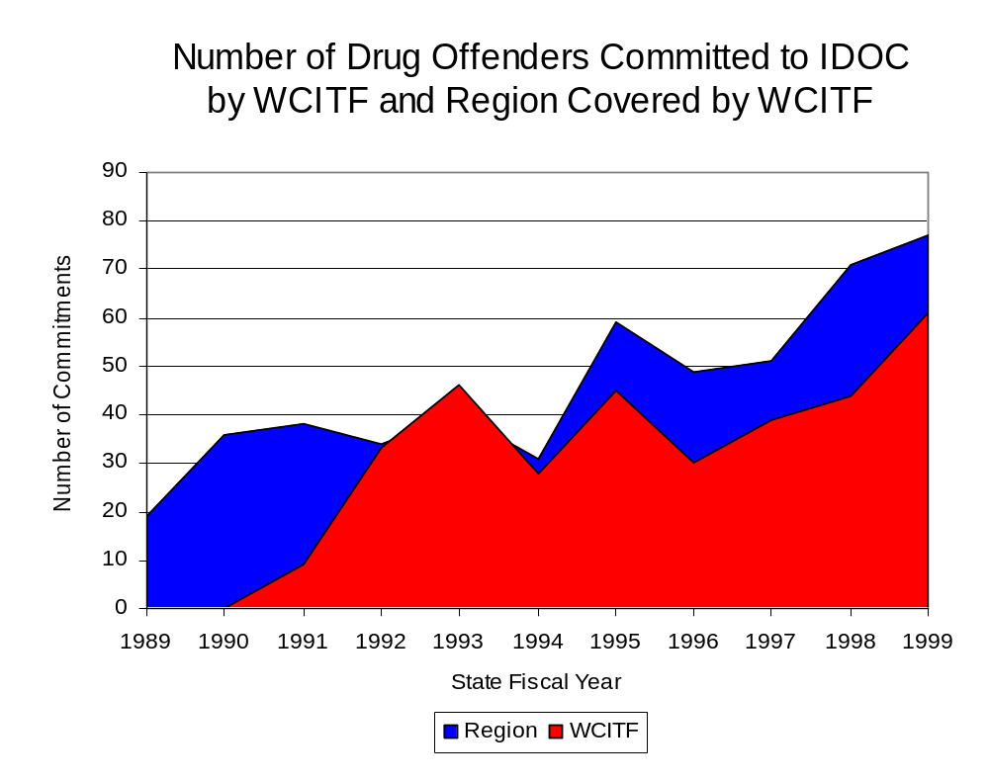
Figure 21
Source: Illinois Department of Corrections and WCITF

During the period analyzed, drug offenders accounted for an increasing proportion of adults convicted and sentenced to prison from Adams, Brown, Fulton, Hancock, Henderson, McDonough, Pike and Warren counties. In 1989, drug offenses accounted for 11 percent of all commitments to IDOC, compared to 28 percent in 1999 (Figure 22).
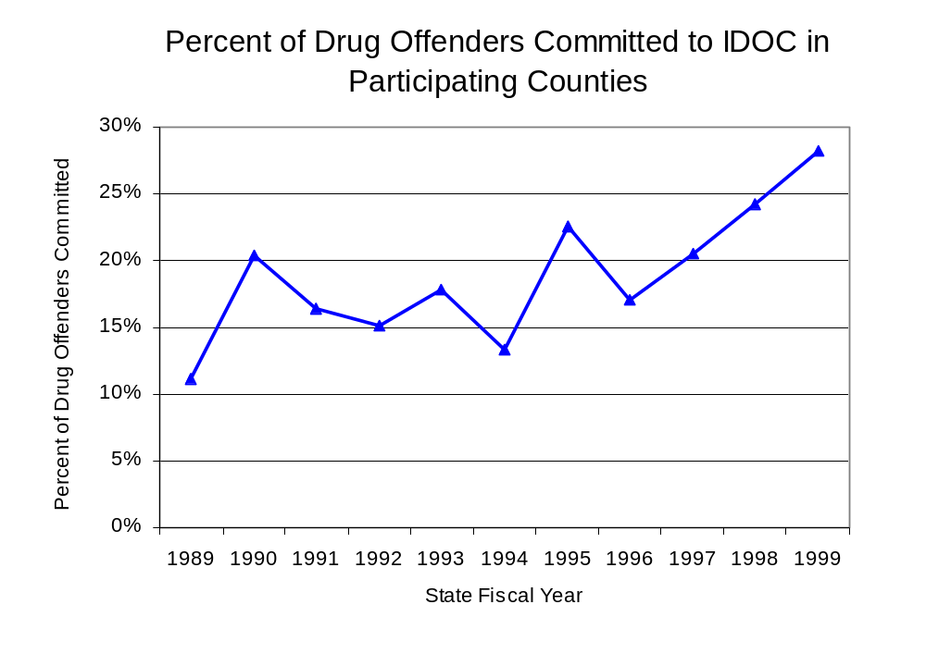
Figure 22
Source: Illinois Department of Corrections

Penalties for drug offenses were also examined between 1993 and 1999. Class 4 felonies accounted for the largest proportion (50 percent) of sentences to IDOC for drug offenses, followed by Class 3 felonies (17 percent), Class 2 and Class 1 felonies (16 percent and 14 percent, respectively) and Class X felonies (3 percent). Between 1993 and 1999, the number of Class 4 felony sentences increased nearly five-fold, from six to 35, while Class 2 and Class 3 felony sentences more than tripled, from five to 16 and five to 17, respectively. Class 1 felonies, increased slightly from six to seven, while the number of sentences for Class X felonies remained unchanged at two in both 1993 and 1999 (Figure 23).

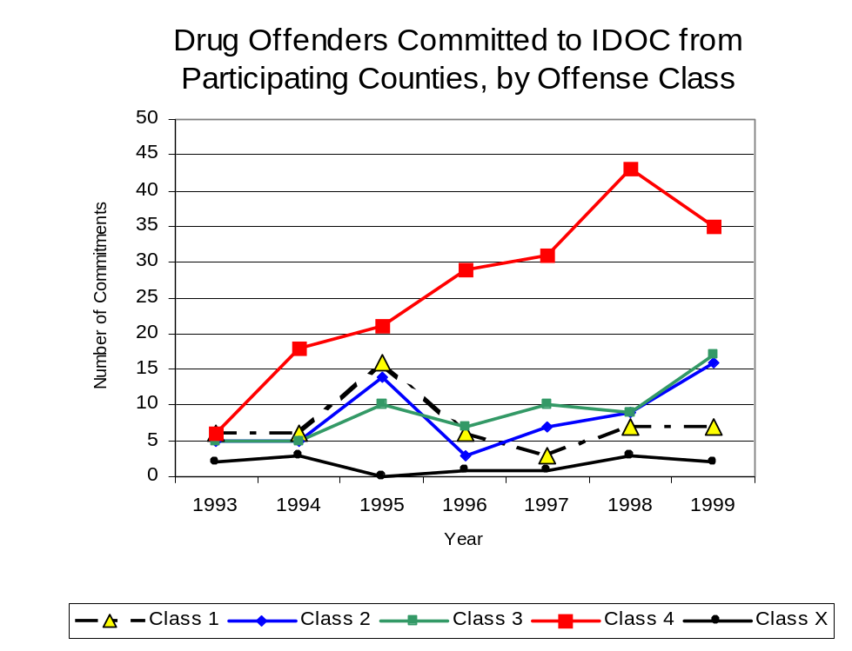
Figure 23
Source: Illinois Department of Corrections

Similar to the increase in Class 4 felony sentences to IDOC between 1993 and 1999, the mean sentence length for Class 4 felonies increased 42 percent, from 2.1 to 2.9 years during the period. In addition, the mean sentence length for Class 1 felony increased 27 percent, from 6.2 to 7.9 years, while Class 3 felonies increased 6 percent, from 3.7 to 3.9 years and Class X sentence lengths increased 5 percent, from 10 to 10.5 years. Conversely, the mean sentence length for Class 2 felonies decreased 10 percent during the period analyzed, from 5.4 to 4.8 years.

VII. Trends in Drug Treatment Admissions in WCITF Region by Drug Type

In addition to considering indicators of the extent and nature of drug abuse as reported through the criminal justice system (for example, arrests and prison sentences), there are indicators of substance abuse available from other Illinois social service agencies. Overseeing and supporting treatment for substance users, whether they are referred from the criminal justice system or elsewhere, is the responsibility of the Illinois Department of Human Services’ Office of Alcoholism and Substance Abuse (OASA). It is important to note, however, that while OASA data represent the majority of the overall demand for substance abuse treatment in the state, some private programs provide treatment services to a smaller but significant number of clients who may not be included in the state’s reporting system.

In state fiscal year 1999, OASA reported 1,804 admissions for alcohol or drug abuse treatment from Adams, Brown, Fulton, Hancock, Henderson, McDonough, Pike and Warren counties, 32 percent more than the 1,370 admissions in 1989 (Figure 24). Among the 1,804 admissions to substance abuse treatment in state fiscal year 1999, 58 percent (1,052) reported alcohol as their primary substance of abuse, while abuse of illicit substances accounted for 40 percent. One percent reported no primary substance of abuse.
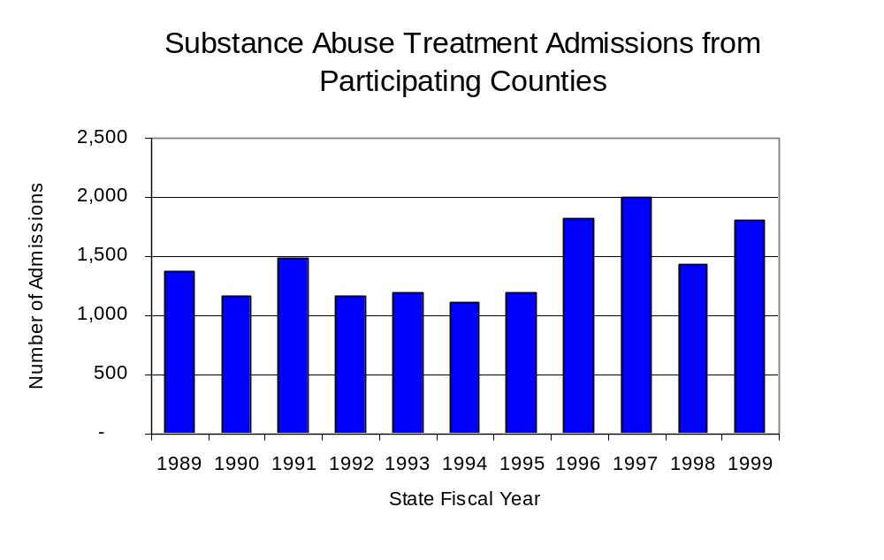
Figure 24
Source: Illinois Department of Human Services’
Office of Alcoholism and Substance Abuse

While drug treatment admissions can be considered a measure of the demand placed on a specific component of the human services system within Illinois, the extent and nature of drug treatment admissions could also be indicative of the substance abuse problem within a particular region. In some respects, the characteristics of those admitted to drug treatment can be considered a profile of the most serious drug abusers in the community, since admission to treatment requires a documented, formal assessment of a drug problem and a level of substance abuse warranting treatment. By comparing the types of drugs of abuse reported by those admitted to substance abuse treatment with the types of drugs involved in law enforcement agency arrests, one can get a sense of the degree to which arrests reflect the drugs which are most problematic within a community.

In the following analyses, the percent of arrests accounted for by drugs classified under Illinois’ Controlled Substances Act (primarily cocaine, heroin, and methamphetamine) versus the Cannabis Control Act (marijuana) across the participating agencies combined, non-participating agencies combined and WCITF are compared to the proportion of drug treatment admissions accounted for by these groups of substances. From these comparisons, a number of general conclusions can be made. First, the proportion of arrests made by WCITF accounted for by drugs other than marijuana (Controlled Substances Act offenses) were very close to the proportion of drug treatment admissions from the covered region accounted for by these substances. Thus, there is considerable convergence between the drugs involved in drug arrests and treatment admissions. The majority of arrests by WCITF and local police departments (those agencies participating in WCITF and non-participating agencies) were for cannabis offenses. On the other hand, the majority of arrests by local police departments (including those participating in WCITF and non-participating agencies) were for cannabis offenses. Thus, while local arrests may reflect the most widely available and used drug in the region, they tend not to involve the substances considered to be most serious (i.e., felony versus misdemeanor) nor the substances individuals are seeking and receiving treatment for (Figure 25).

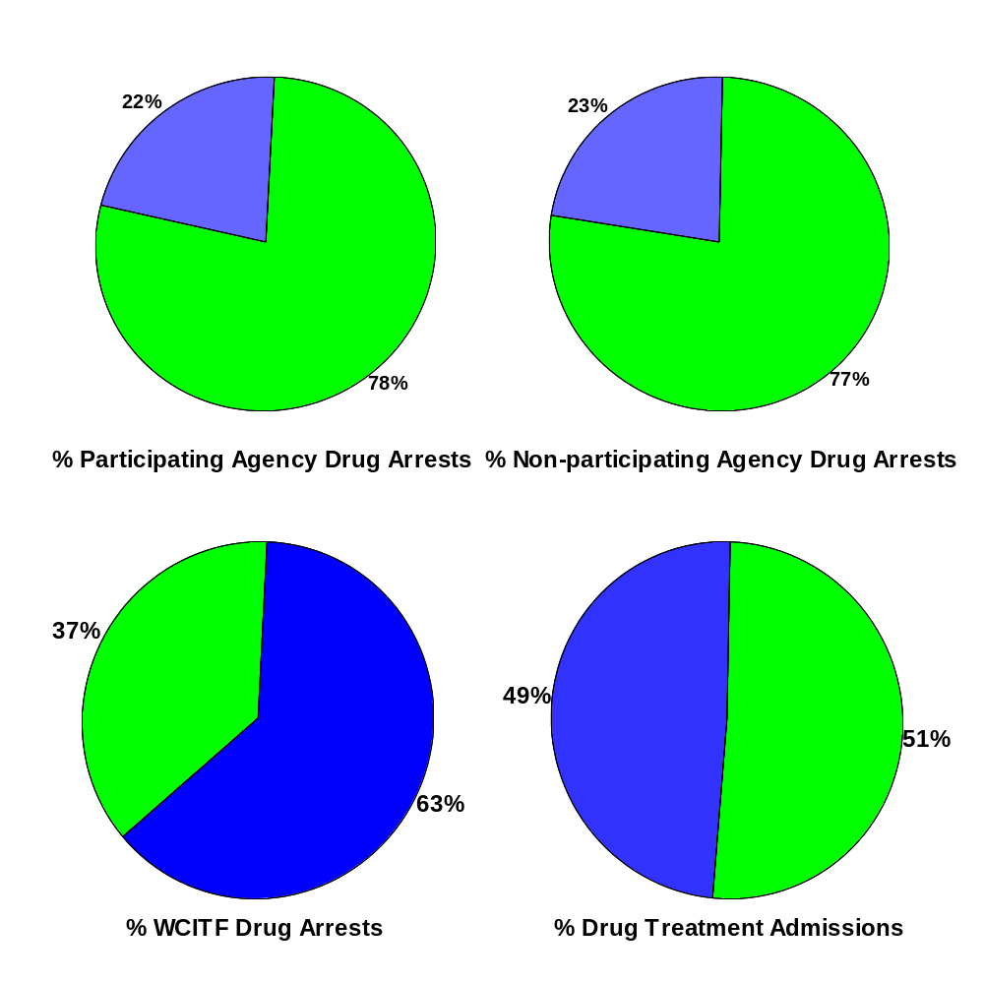
CannabisControlled Substances
Comparison of Drug Arrests by WCITF and Participating and Non-participating Agencies vs. Drug Abuse Treatment Admissions in from Adams, Brown, Fulton, Hancock, Henderson, McDonough, Pike and Warren Counties, 1999
Source: Illinois Department of Human Service's Office of Alcoholism and Substance Abuse and WCITF
Figure 25

VIII. Trends in Drug Exposed Births

Illinois continues to experience the effects of prenatal substance abuse. In Illinois, if a baby is born and thought to have been exposed to illegal substances or alcohol, either through observation by physicians or toxicology tests, the case is reported to the Illinois Department of Children and Family Services. These cases are then investigated by DCFS to verify the child’s prenatal exposure to either alcohol or illegal substances. Between state fiscal years 1989 and 1999, nearly one-half (50) of Illinois’ 102 counties reported at least one case of a substance-affected infant.

Between state fiscal years 1989 and 1999, the number of drug-exposed infant cases reported in the eight-county region covered by WCITF increased from two to 11. Between state fiscal years 1989 and 1999, 30 cases, or 68 percent of all cases reported, were verified as involving prenatal drug use by a DCFS investigation. Mirroring the trend of reported cases, verified cases of drug-exposed infants in the WCITF region also increased between 1989 and 1999 from one to 11 (Figure 26).
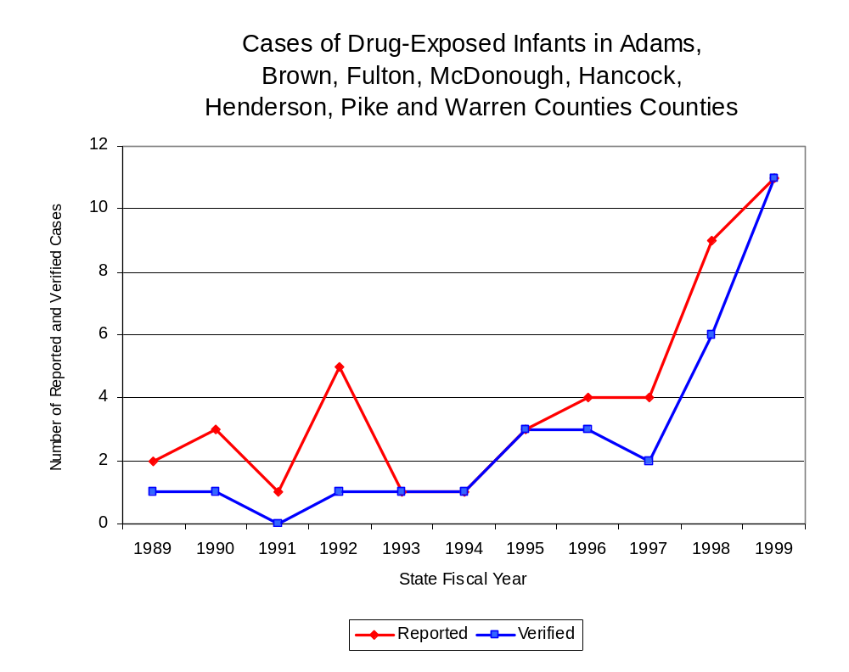
Source: Illinois Department of Children and Family Services
Figure 26

IX. Summary of Drug Situation

Although the distribution of illegal drugs is difficult to measure precisely, data obtained from criminal justice sources can be helpful in estimating drug availability. Information from a recent survey of Illinois drug enforcement units, as well as the most up-to-date data available on drug price, are presented as indicators of the drug supply in Illinois.

In 1995, 1996 and 1998, the Authority conducted a survey of each MEG and task force in Illinois to gauge the perceived availability of drugs in the areas they cover. Questions were asked concerning the availability of specific drugs, and results were analyzed by region of the state. MEGs and task forces are classified as being either urban, rural or mixed urban/rural based upon the classification of the county(s) that each unit covers, and, for purposes of this report, are compared to the average of similar units.

According to WCITF survey responses, cannabis, cocaine, crack and methamphetamine continued to be the most visible drugs on the street and were all reported to be “readily available” across all regions analyzed. While perceived availability of cannabis, crack, methamphetamine and LSD remained relatively unchanged in the eight-county region covered by WCITF, the perceived availability of cocaine, heroin and PCP decreased slightly since the 1996 survey. Methamphetamine was reported as moderately available across Illinois but available to a greater degree in the region covered by WCITF and by all MEGs and task forces in mostly rural regions. The perceived availability of cocaine, heroin and PCP tended to be greater across Illinois and in other mostly rural regions than in the region covered by WCITF (Figure 27).
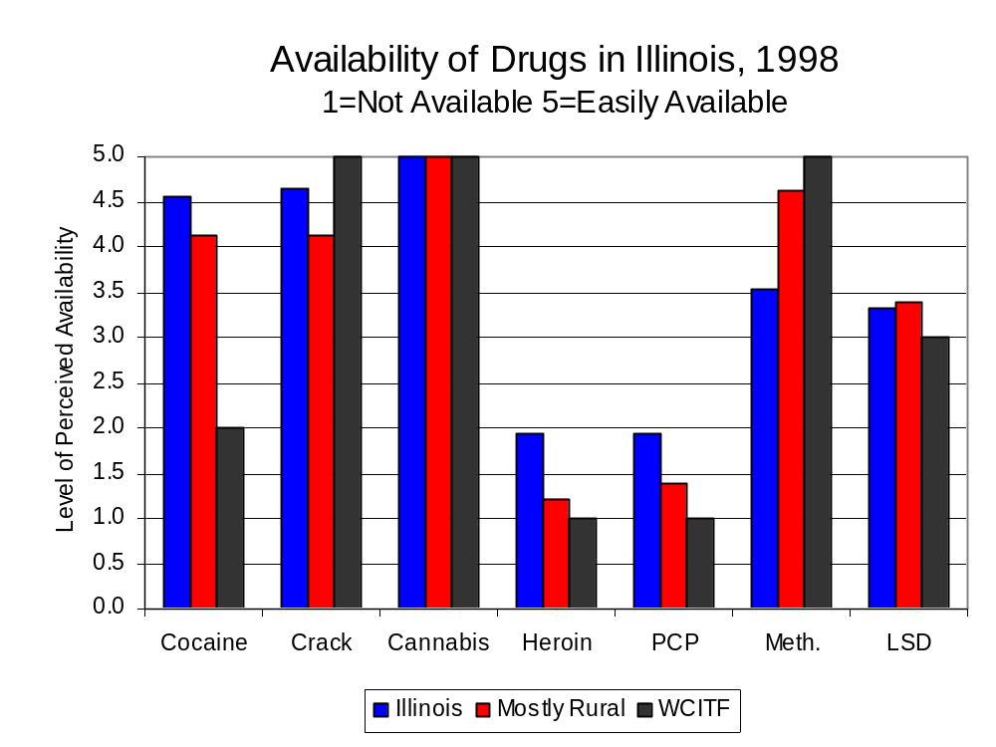
Figure 27
Source: Authority Survey of Illinois MEGs and task forces
Another market indicator that can be used to assess availability is drug price. Lower prices tend to suggest a sufficient supply to meet demand, while increasing prices indicate decreased availability.

Based on a statewide survey of MEG and task force units, the average price of cocaine, crack, cannabis and methamphetamine appear to be relatively stable across all regions surveyed in 1998, while prices for heroin and PCP appear to vary somewhat across Illinois. The average price of cocaine and crack in the region covered by WCITF remained unchanged between 1996 and 1998, while it increased in the other mostly rural regions. The 1998 average price of cocaine reported by WCITF was $100 per gram, compared to $98 per gram across Illinois and all MEGs and task forces in other mostly rural regions (Figure 28). On the other hand, the average price of crack in the region covered by WCITF was reported as $100 per gram, lower than the price of $102 per gram across Illinois and the price of $109 per gram reported by all other MEGs and task forces in mostly rural regions. Between the 1996 and 1998 surveys, the average price of methamphetamine increased across Illinois and the eight-county region covered by WCITF, while decreasing slightly across all MEGs and task forces in other mostly rural regions. In 1998, the average price of methamphetamine was reported as approximately $100 per gram in the WCITF region (compared to $80 per gram in 1996), which is higher than the $94 per gram in mostly rural regions ($95 in 1996) and $96 per gram across Illinois ($74 in 1996). In 1998, the average price of cannabis was reported as approximately $10 per gram in the WCITF region and $8 per gram in mostly rural regions and across Illinois.

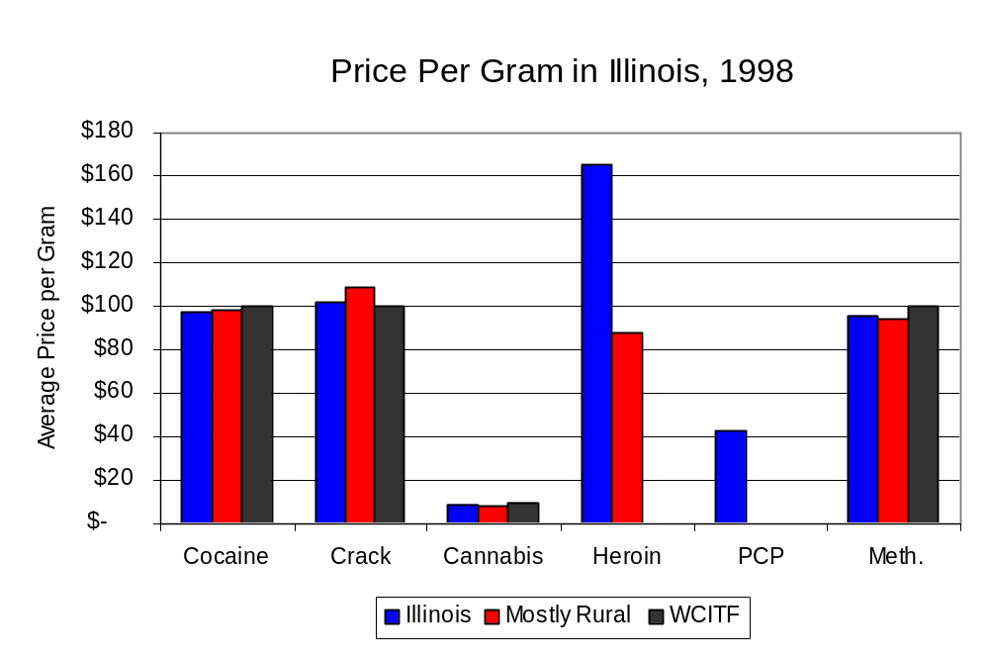
Figure 28
Source: Authority Survey of Illinois MEGs and task forces

X. Appendices
1999 Percent of Illinois'
County-level Population Covered by an Authority-funded Multi-jurisdictional Enforcement Group or Task Force
Map 1
* Shaded counties indicate that at least one law enforcement agency within the county participates in a MEG or task force
Percent of County Population Covered by MEG or Task Force

1999 Illinois
Cannabis
Seizure Rates, by County
Map 2
Cannabis Seizure Rate
(rate per 100,000 population)
1999 Illinois
Cocaine
Seizure Rates, by County
Map 3
Cocaine Seizure Rate
(rate per 100,000 population)
1999 Illinois Methamphetamine
Seizure Rates, by County
Map 4
Methamphetamine Seizure Rate
(rate per 100,000 population)

Bibliography

Administrative Office of the Illinois Courts, Annual Report to the Supreme Court of Illinois.
1989 through 1999 reports, Springfield, Illinois.

Administrative Office of the Illinois Courts’ Probation Division, Statewide Probation Data
Report. 1989 through 1999 reports, Springfield, Illinois.

Illinois Department of Human Services’ Office of Alcoholism and Substance Abuse. Data
provided for state fiscal years 1989 through 1999, Springfield, Illinois.

Illinois Department of Children and Family Services, Child Abuse/Neglect Statistics Report,
1989 through 1999 reports, Springfield, Illinois.

Illinois Department of Corrections. Data provided for fiscal years 1989 through 1999,
Springfield, Illinois.

Illinois State Police, Crime in Illinois. 1993 through 1999 reports, Springfield, Illinois.

Illinois State Police, Drug Statistics Report. Monthly reports, January 1989 through
December 1999, Quincy, Illinois.

West Central Illinois Task Force. Monthly reports, January 1989 through December
1999, Quincy, Illinois.

U.S. Bureau of the Census.


George H. Ryan, Governor
Peter B. Bensinger, Chairman
Candice M. Kane, Executive Director

